**How to install Oracle Database 18c XE on Windows**

Get up and running with the free Oracle Database edition on Windows

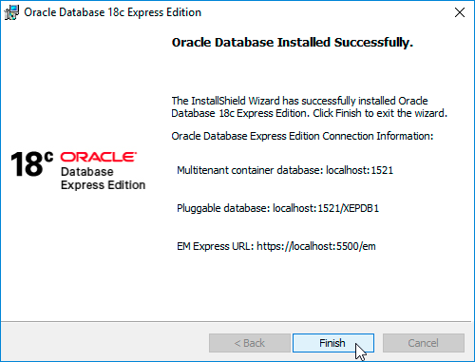

# Preparing for the installation

Before you can start the installation, you will have to download the Oracle Database 18c XE Windows installer zip file. Head over to <https://www.oracle.com/technetwork/database/database-technologies/express-edition/downloads/index.html>, click on “**Accept License Agreement**” and download the “**Oracle Database 18c Express Edition for Windows x64**” zip file.

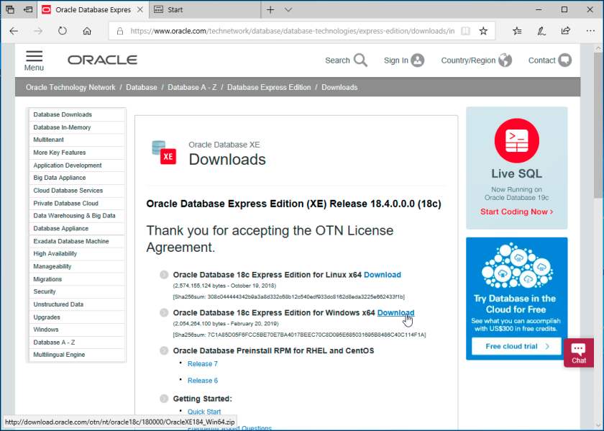

Once you have downloaded the zip file, extract it anywhere.

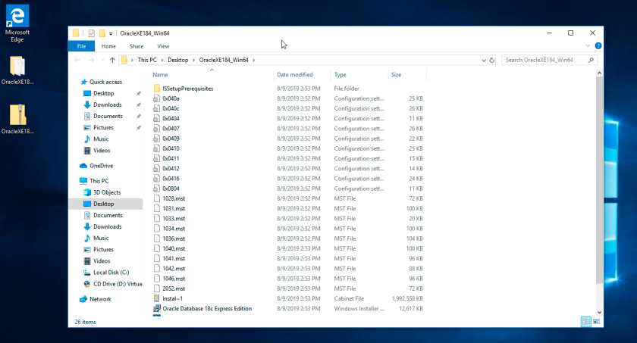

# Installing Oracle Database 18c XE

Go into the extracted Oracle 18c XE Installer directory and double-click on setup.exe. **Important: Do not** double-click on Oracle Database 18c Express Edition.msi.

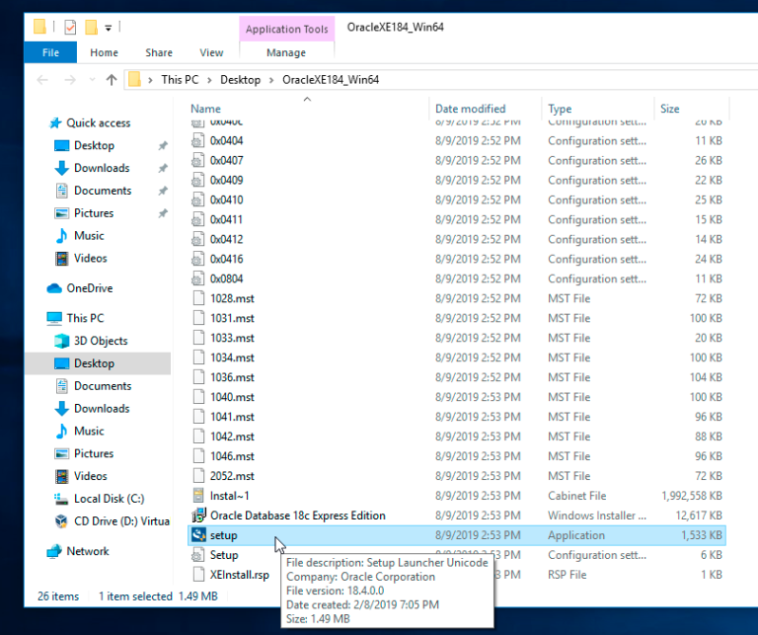

Click “**Yes**” when Windows asks you whether you want to allow this app to make changes to your device.

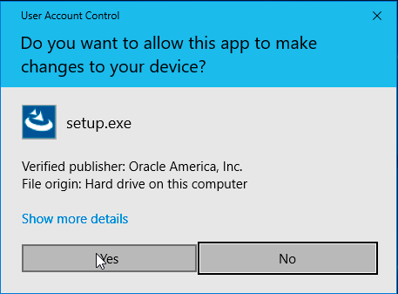

The installer will start up now, click “**Next**“.



Read the license agreement and click “**I accept the terms in the license agreement**“. Then click “**Next**“**.**

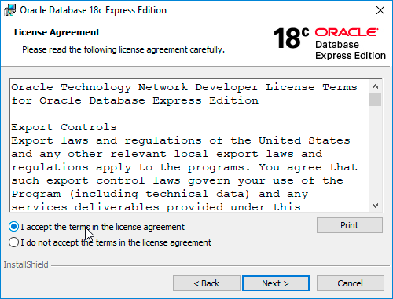

Choose a destination folder for where Oracle 18c XE should be installed into, or accept the default location. Then click “**Next**“**.**

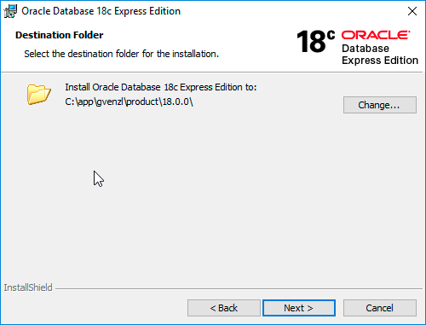

Specify and confirm a database password. This is the password that will be set for the SYS, SYSTEM and PDBADMIN accounts, which you will later use to connect to the database directly. Then click “**Next**“**.**

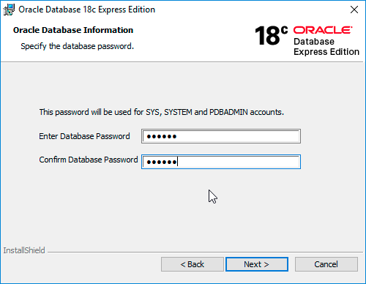

On the next screen you will see the summary and confirmation of the destination folders for Oracle Database 18c XE. Click “**Install**“.

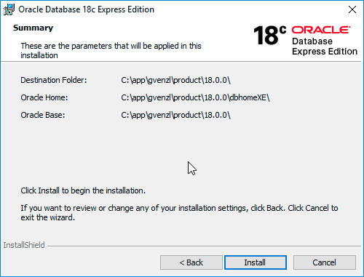

Now 18c XE is being installed, this can take several minutes.

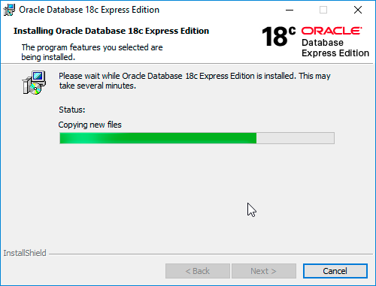

If you have the Windows Defender Firewall activated, you will be asked to allow network access to the Java Platform SE binary. Check the checkboxes to allow access to the networks of your choice and click the “**Allow access**” button. **Note:** If you do not allow network access for Java, some features of Oracle Database 18c XE might not work correctly.

[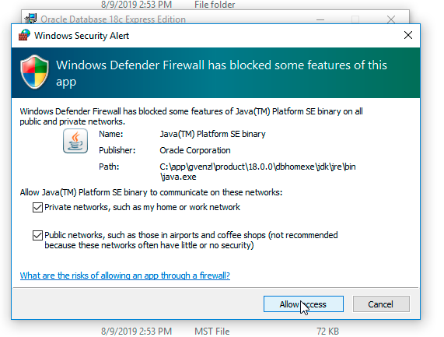](https://venzi.files.wordpress.com/2019/08/oracle-database-18c-xe-windows-firewall.png)

The installation will proceed. Once it is finished, you will be presented with a “**Oracle Database Installed Successfully**” summary screen that also lists the container database, pluggable database and Enterprise Manager Express connection details. Click on “**Finish**“.

[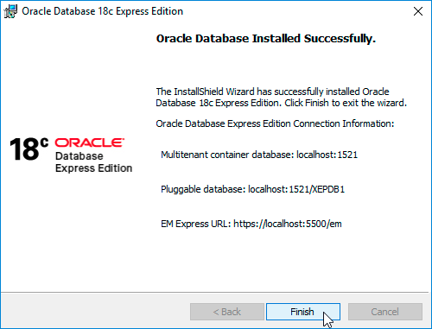](https://venzi.files.wordpress.com/2019/08/oracle-database-18c-xe-successful-installation.png)

Congratulations, you now have Oracle Database 18c XE installed on your Windows machine.

Note: To install Oracle XE on a Linux machine, follow the steps from here (<https://docs.oracle.com/en/database/oracle/oracle-database/18/xeinl/index.html>)